

Marmara University Faculty of Engineering
PHYS 1103 PHYSICS LABORATORY I

Measurements Errors and Uncertainty

Section: 2
Group: 1
Submitted to: Arş. Gör. Hüseyin YALTIRIK Due Date: 29.10.2024

 | Dept ID | Student I | Name / Surname | Contribution
1 | BIOE |  |  | Conclusion, Calculations, Results, Theory
2 | BIOE |  |  | Conclusion, Calculations, Results, Theory
3 | BIOE |  |  | Conclusion, Calculations, Results, Theory, Upload

Table of Contents
1. PURPOSE 3
2. THEORY 3
3. EXPERIMENTAL SETUP 3
5. CALCULATIONS AND RESULTS 3
6. CONCLUSION 6
7. REFERENCES 11
8. APPENDIX 12

PURPOSE
The purpose of this experiment is to learn how to use a caliper and a ruler correctly. It aims to understand the difference in measurements between the caliper and the ruler, identify errors, and analyze the results by comparing them.

THEORY
Using a ruler and caliper with different precision, even when the same measurements are made by three different people, can lead to differences in results.

EXPERIMENTAL SETUP

A List of Materials

Ruler (margins of error 0.05 cm)

Caliper (margins of error 0.01 mm)

Precision scale

Rectangular prism

Cylinder prism

Cube

CALCULATIONS AND RESULTS
- Rectangular Prism
Measurements of the Rectangular Prism Using Ruler and Caliper
We all took turns measure the rectangular prism by using a ruler and a caliper. The results are given below.
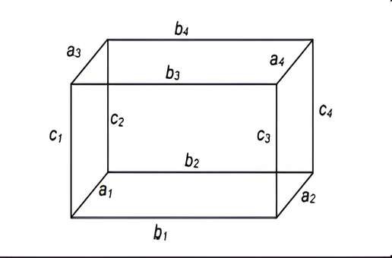
By given equations and measured data, we are going to calculate average of each edge and calculate volume of rectangular prism.

Ruler (cm) | b±Δb | a±Δa | c±Δc
1 | 5.40±0.05 | 3.40±0.05 | 4.50±0.05
2 | 5.40±0.05 | 3.50±0.05 | 4.50±0.05
3 | 5.50±0.05 | 3.50±0.05 | 4.50±0.05
Average | 5.43±0.05 | 3.43±0.05 | 4.50±0.05

Table 1.1 Measuring dimension of the object

Caliper (mm) | b±Δb | a±Δa | c±Δc
1 | 55.20±0.01 | 35.10±0.01 | 45.00±0.01
2 | 55.10±0.01 | 35.10±0.01 | 45.20±0.01
3 | 55.15±0.01 | 35.00±0.01 | 45.00±0.01
Average | 55.15±0.01 | 35.06±0.01 | 45.06±0.01

Table 1.2 Measuring dimension of the object

From this average data of the measurement we calculate volume of the object.
 | By ruler | By Caliper
V± ΔV (cm³) | 83.82 cm³ | 87.32 cm³

Table 1.3 Results of the calculation of the volume of the object from dimensional measurements.

To make a calculation for density, we weigh the object three times and calculated the average. We used the digital scale for this.
By digital balance (in unit of gram)
m ± Δ m
1 | 122.05 g
2 | 122.04 g
3 | 122.06 g
Average | 122.05 g

Table 1.4 Measuring mass of the object

To calculate the density of the object, according to calculations we fill this table.
Density (g/cm³⁾ | By ruler | By Caliper
By digital balance | 1.46 g/cm³ | 1.40 g/cm³

Table 1.5 Calculating density of object

- Cylinder
Measurements of the Cylinder Using Ruler and Caliper
Next, we are going to repeat the initial process for cylindrical project. We all took turns measure the cylinder by using a ruler and caliper. The results are given below and we calculated the average of the cylinder’s edge.
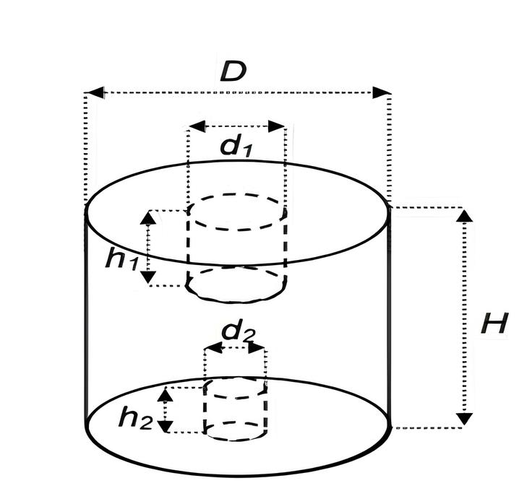

Ruler (cm) | D ±Δ D | H ±ΔH
1 | 4.3±0.05 | 6.0±0.05
2 | 4.4±0.05 | 5.9±0.05
3 | 4.5±0.05 | 6.1±0.05
Average | 4.4±0.05 | 6.0±0.05

Table 1.6 Measuring dimension of the object

Caliper(mm) | D ±Δ D | H ±ΔH
1 | 45.10±0.01 | 60.30±0.01
2 | 45.10±0.01 | 61.00±0.01
3 | 45.00±0.01 | 59.08±0.01
Average | 45.06±0.01 | 60.13±0.01

Table 1.7 Measuring dimension of the object

With this information we are going to calculate values specially wanted from us.
 | By ruler | By caliper
V± ΔV (cm3) | 91.23 cm³ | 95.89cm³

Table 1.8 Results of the calculation of the volume of the object
To calculate the density, we weigh the object and calculated the average weight.
 | By digital balance (in unit of gram) m ± Δ m
1 | 131.30 g
2 | 131.32 g
3 | 131.31 g
Average | 131.31 g
Table 1.9 Measuring mass of the object

From this data we will calculate the density.
Density (g/cm3) | By ruler | By caliper
By digital balance | 1.44 g/cm3 | 1.37 g/cm3

Table 2.0 Calculating density of object

- Cube
Measurements of the Cylinder Using Ruler and Caliper
Lastly, we are going to repeat the previous process for cube project. We all took turns measure the cube by using a ruler and caliper. The results are given below and we calculated the average of the cube’s edge.

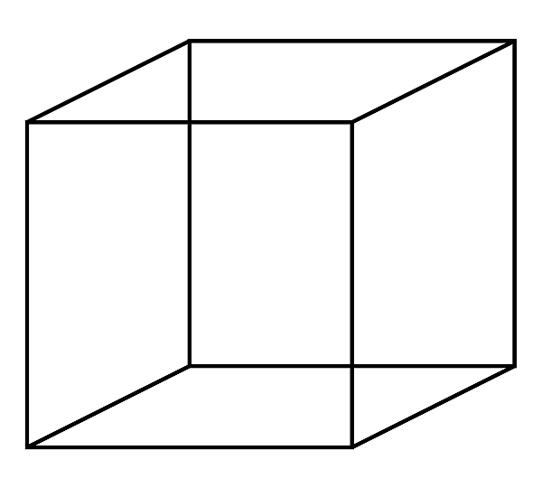
a
a
a

Ruler (cm) | a ±Δ a
1 | 4.5±0.05
2 | 4.5±0.05
3 | 4.5±0.05
Average | 4.5±0.05

2.1 Measuring dimension of the object
Caliper (mm) | a ±Δ a
1 | 45.12±0.01
2 | 45.00±0.01
3 | 45.11±0.01
Average | 45.11±0.01

2.2 Measuring dimension of the object

From this average data of the measurement we calculate volume of the object.
 | By ruler | By caliper
V± ΔV (cm3) | 91.13 cm³ | 91.55cm³

Table 2.3 Results of the calculation of the volume of the object

To calculate the density, we weigh the object and calculated the average weight.
 | By digital balance (in unit of gram) m ± Δ m
1 | 128.44 g
2 | 128.46 g
3 | 128.42 g
Average | 128.44 g

Table 2.4 Measuring mass of the object

From this data we will calculate the density.

Density (g/cm3) | By ruler | By caliper
By digital balance | 1.41 g/cm3 | 1.40 g/cm3

Table 2.5 Calculating density of object

CONCLUSION
In this experiment, we learned how to use calipers and rulers for measurements. As a result of this, we compared the differences between these two measurement tools.
First, we measured and weighed the objects using both the ruler and the caliper, then take notes and according to data we calculated their average measurements and grams. After that, we determined their volumes and calculated their densities. In addition, we compared of the differences between the results and saw the importance of the using the right measuring tool.

REFERENCES
- https://www.youtube.com/watch?v=vkPlzmalvN4
- https://www.youtube.com/watch?v=0TLkSBD93ec
- https://www.youtube.com/watch?v=ySRN3yuZUT0
- https://www.youtube.com/watch?v=4hlNi0jdoeQ&t=9s
- https://www.youtube.com/watch?v=Tu-CzS3Uk-8
- 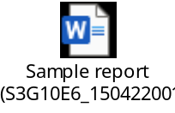

APPENDIX

- 